COMP 3270 Assignment 4 (100 points)

**Due by 11:59PM on Monday, November 28th, 2022**

Instructions:

1. Late submissions **will not** be accepted unless prior permission has been granted or there is a valid and verifiable excuse.
2. Think carefully; formulate your answers, and then write them out concisely using English, logic, mathematics and pseudocode (no programming language syntax).
3. Type your final answers in this Word document.
4. Don’t turn in handwritten answers with scribbling, cross-outs, erasures, etc. If an answer is unreadable, it will earn zero points. **Neatly and cleanly handwritten submissions are acceptable**.

**1. (15 points)** Show d and π values that result from running Breadth First Search on the directed graph below using vertex 3 as the start node.

d=∞

d=3

π =nil

π =4

d=0

π =nil

d=1

π =3

π =5

π =3

d=2

d=1

**2. (10 points)** Show how Depth First Search works on the graph below by marking on the graph the discovery and finishing times (d and f) for each vertex and the classification of each edge. Assume that the for loops in DFS and DFS-VISIT consider vertices alphabetically.

(17,20)

(8,15)

(2,7)

(3,6)

(1,16)

(2,7)

(18,19)

(4,5)

Tree edges: (q,s)(s,v)(v,w)(q,t)(t,x)(x,z)(t,y)(r,u)

Backwards edge: (w,s)(y,q)

Forward edges: (q,w)

Cross edges : (r,y)(u,y)

(9,12)

(10,11)

**3. (15 points)** List the vertices of the graph below in Topological Order, as produced by the Topological Sort algorithm. Assume that the for loops in DFS and DFS-VISIT consider vertices alphabetically.

P, N, O, S, M, R, Y, U, X, W, Z, U

**4. (15 points)** Do Problem 24.1-1 (p. 654) (you do not have to do the last part, i.e., running the algorithm again after changing an edge weight).

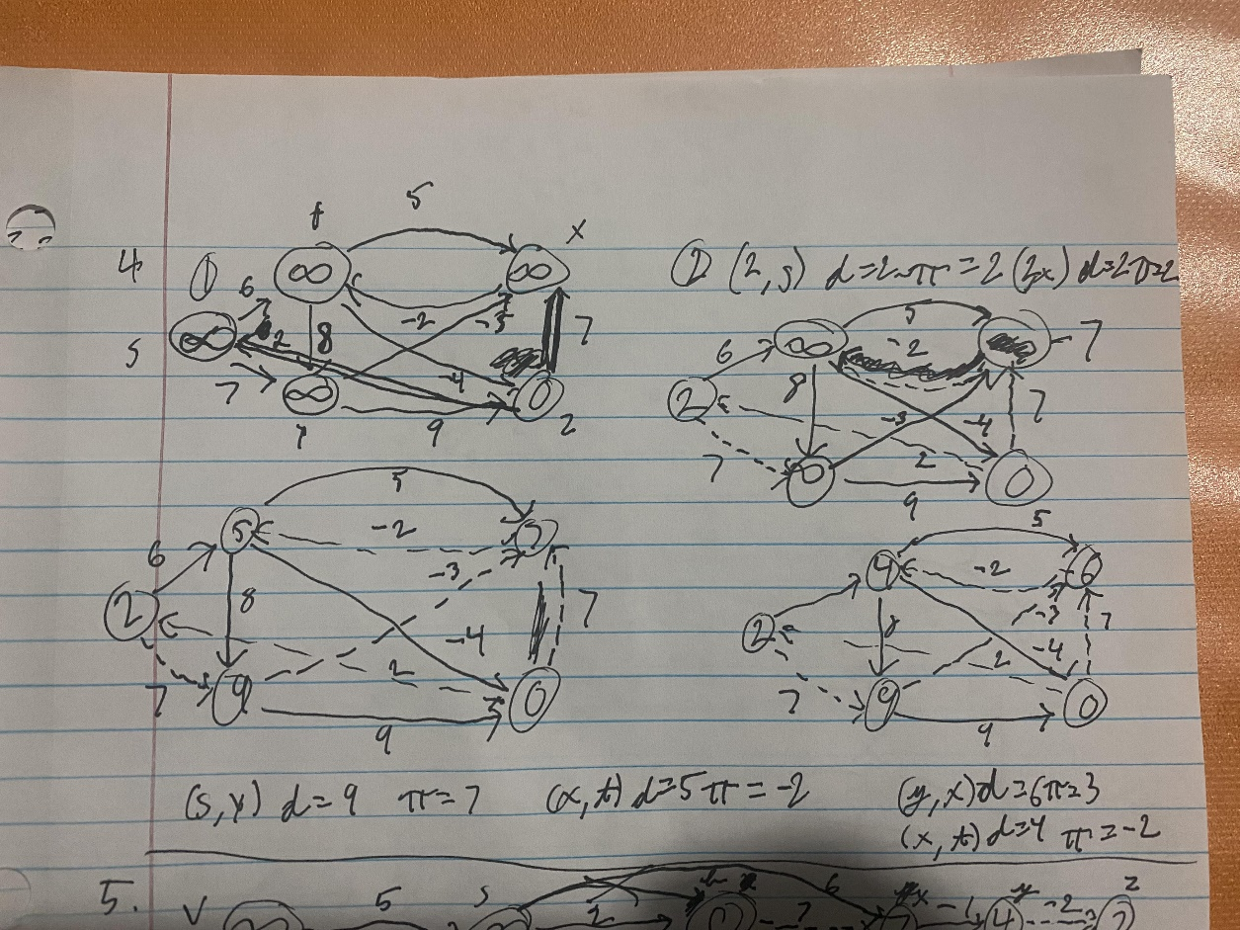

**5. (15 points)** Do Problem 24.2-1 (p. 657 of the recommended text). Show the results similar to Fig. 24.5.

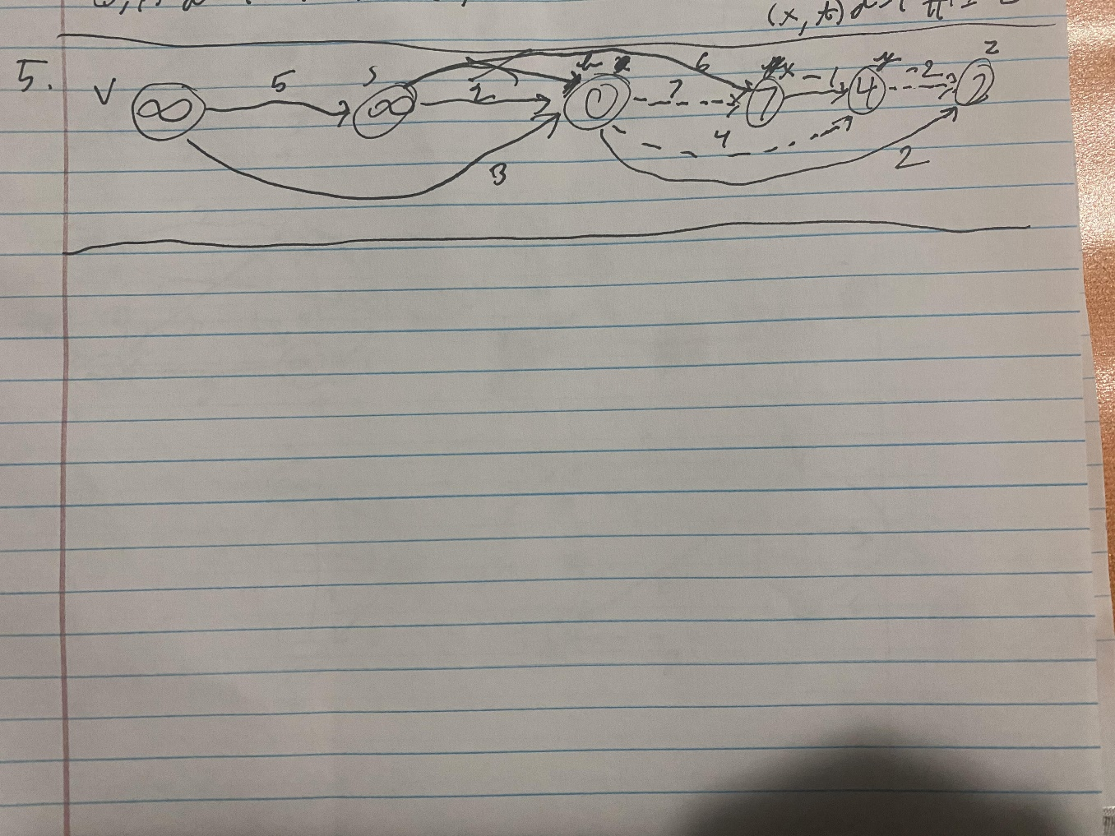

**6. (20 points)** Do Problem 24.3-1 (p. 662 of the recommended text).

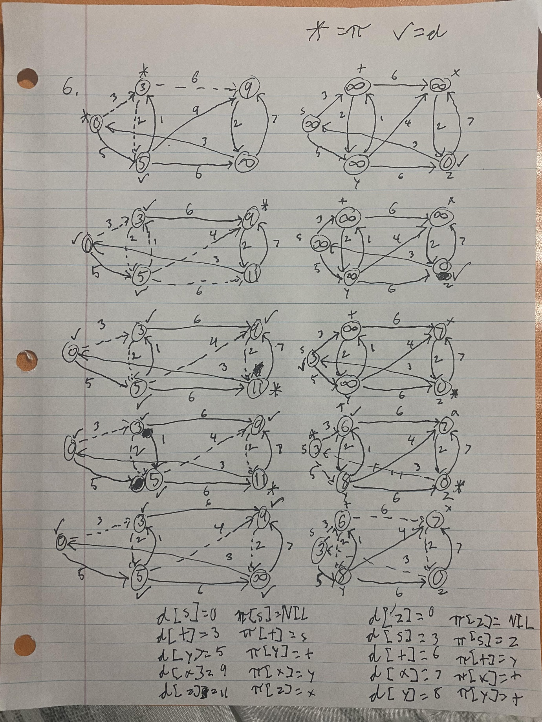

**(7) (10 points)** Supposethat a graph G has a Minimum Spanning Tree (MST) computed. How quickly can we update the MST if we add a new vertex and incident edges to G. Propose and outline a strategy and present an algorithm (you can reuse graph algorithms covered in class as building blocks as part of your solution) and evaluate its asymptotic complexity.

The greedy method chooses the min-weight edge and if the edge doesn’t create a cycle it add it to the tree.

For finding and deleting the min-weight edge, use min-heap where the nodes are the labels of the tree and the weight of the graph edges

The cycle detector:

T is a tree for any time

Adding the edge gets rid of the 2 trees and replaces them by adding a brand-new tree containing the union of the nodes of the 2 old trees

Edge e (x,y) creates a cycle if x and y are in the same tree